**SOFTWARE REQUIREMENT SPECIFICATION**

**FOR**

**RAJAPAKSHA GARDEN RESERVATION SERVICE**

**NEKFA AUSTRLIA (PVT) LTD**

4th Floor, 131, W A D Ramanayake Mawatha, Colombo 02

Tel: 011 2375062| email: info@nekfa.com

www.nekfa.com

Document Acceptance

|  |  |
| --- | --- |
| Deliverable | Software Requirement Specification- Cemetery Service |
| Deliverable Date |  |
| Client | Negombo Municipal Council |

NEKFA Australia (PVT) LTD

|  |  |
| --- | --- |
| Name and Designation | Signature |
|  |  |
|  |  |

Document Amendment Register

|  |  |  |
| --- | --- | --- |
| Date | Author | Reviewer |
|  |  |  |

Table of content

Introduction

Scope of the project

Intendant audience and Users

Introduction

**Purpose**

This document describes the Software Requirements Specification for the Rajapakshe garden Reservation .The Purpose of this document is to provide guidelines for the development of the Garden Reservation Portal.

**Scope of the project**

The Scope of this SRS document is to define the functional requirements for Rajapakshe garden reservation of Negombo municipal council and its component like User management. It also defines user interfaces, user characteristics, sitemap, navigation etc. for the portal.

It also covers the non-functional requirements like performance, reliability, availability, security, maintainability etc.

The proposed system will facilitate the introduction of a new solution that could enhance and improve the service standards offered to the customer. The Purpose of this document is to provide guidelines for the development of the garden reservation system.

**Intendant audience and Users**

**Customer**

**Admin**

**Development team**

**Overall descriptions**

**Product perspective**

**System features**

1. **Request service(Fill the application)**

**Flow chart**

**Scenario –**

**Actor –**

**Precondition –**

**Description -**

Select the option

View the instructions

Confirm instruction

Enter the data for application

Click submit

If user want clear click clear icon.

|  |  |  |  |  |
| --- | --- | --- | --- | --- |
| Field | Field Type | Length | Priority | Comment |
| Applicant Name | Text field |  | Mandatory |  |
| NIC | Text field |  | Mandatory |  |
| Address | Text field |  | Mandatory |  |
| Mobile Number | Numeric |  | Mandatory |  |
| Reservation date | Date/Time |  | Mandatory |  |
| Reservation Time | Date/Time |  | Mandatory |  |
| Reason | Text field |  | Mandatory |  |

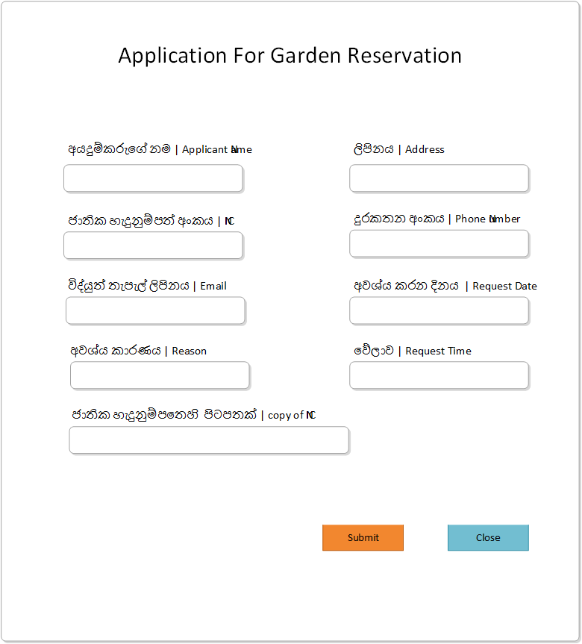

**System shall be able to send message to admin.**

1. **Online payment**

**Flow chart**

**Scenario –**

**Actor –**

**Precondition –**

**Description –**

Click approved application

Go to payment

Pay payment

Confirm payment

If not close payment.

**Admin login**

**Flow chart**

**Description**

**Scenario** Admin login into the system.

**Actor** Admin

**Precondition 1.** The admin should be having internet connection.

Admin will login into the system by using credentials (User ID, Password).

|  |  |  |  |  |
| --- | --- | --- | --- | --- |
| **Field** | **Field Type** | **Length** | **Priority** | **Comment** |
| User Id | Text field |  | Mandatory |  |
| Password | Text field |  | Mandatory |  |

**Stimulus/ Responses**

**1. Stimulus:** Admin enters user id and password and signs in to the system.

**Response** System directs to the admin dashboard.

1. **Stimulus:** Admin clicks forgot password button.

**Response:** The system displays a notification to input the email address.

**Error flow**

* System displays an error message to fill in missing fields.

**3.5. 4 Functional Requirements**

**REQ-1:** Admin shall be able to log into the system.

**REQ-2:** System shall be able to direct admin into the Admin dashboard.

1. **Approve application**
2. **Reject application**
3. **Update payment**
4. **Print /download receipt**

**System shall be able to generate a receipt.**

**System shall be able to manage notification.**

**User Interfaces**

Web based Graphical User Interface (GUI) will be provided. Garden reservation Portal will be completely menu driven and user friendly. Portal will be designed so that with minimum number of clicks user should be able to access desired information. Screens will be ergonomically designed. Wherever possible, input fields will be pre-populated.

Product function wise user interfaces such as screen formats for Input forms, output screens, report layouts, menu structures have been explained in subsequent sections.

**Hardware Interfaces**

Users of the Rajapaksha Garden Reservation Portal will be able to access on their client systems, smart phones.

To host the portal, hardware servers will be required for Portal server (Content Management), Application Server, Database, SMS server with adequate back up facilities and disaster recovery mechanism for 24 X 7 availability.

**Software Interfaces**

User will be able to access the portal using web browser on the system having base Operating System. On Server end, in addition to base Operating system, software will be required for internet server, Content Management, Database.

**Software Systems Attributes**

**Availability**

Availability refers to a system or component that is continuously operational for a desirably long length of time. It is an ability to withstand failure of individual components. Central Agricultural portal should be highly available. To make garden reservation solution to be highly available, it is essential that all components like hardware, network, system software, and application software for Garden reservation solution are operational all the time. If the system is not available for all the time, user loses his interest and avoids using the service again presuming that it may waste his/her time in accessing the service without any result.

**Scalability**

Scalability is the ability of a system, network, or process, to handle growing amount of load in a capable manner by means of deploying additional resources, if required, without any noticeable degradation of its performance.

**Usability**

Usability is a quality attribute that assesses how easy user interfaces are to use. Compromising user friendliness leads to loss of productivity. Garden Reservation Portal should be easy to use. The underlying technology should be transparent to users, so they can concentrate on tasks at hand. Screens should be designed for ease of use by non-technical users who do not have any computer knowledge. The GUI design shall be intuitive and task-based without any superfluous design

Use case diagram

